

February 12, 2020

Adopt a Spot – School Pride in Action

Our Burkeville Student Council wanted to be a part in beautifying our school and making it a place that students and staff could be proud of. Along with the help of the administrators and staff, the student council was able to complete this project and help make our school a better place. Many different organizations, classes, and community members collaborated to get this project completed. We all wanted to achieve the goal of making our school a place that makes us proud, and that is exactly what we accomplished.

Our main objective was to improve the look of our campus while boosting school spirit and staff/community involvement in the process. This was a success because we had many different teachers, organizations, and community members sign up to help. A few examples of what was accomplished were murals painted around campus by the art class, painted picnic tables placed around campus by the Burkeville Baptist Church and our 5th grade class, and chain link spirit cups displayed by our student council at the football field. We also had our school board president volunteer to paint the goal posts on the football field and our county judge to place chain link spirit cups in the shape of a mustang in the fence at the baseball field. Our PTO also decided to get involved and decorate our football boy’s locker room.

We had so much support and help from not only our student council members and school, but many community members and organizations as well. Seeing these things around campus makes it feel more welcoming and overall a happier place to be. While the student council was only in charge of one beautification spot, many members felt the need and desire to do more and volunteered to help other people/organizations work on their projects.



February 10, 2020

To Whom It May Concern:

Burkeville Student Council participated in a district wide project this school year. The School Pride in Action project invited school groups, teachers, administrators, and community members to help build pride and spirit in our buildings and on our grounds. One of the projects included a mustang made out of spirit cups being displayed on the fence in front of the school. This project was completed by our local judge and his wife. Some school groups painted murals on blank walls and fences around the district. A local church painted picnic tables that were placed around our football field. An elementary class made a flower bed full of colorful rocks that had inspirational sayings on them.

This project has truly had a positive impact on our campus. A few projects were completed before students began school. This helped create a positive and inviting atmosphere for our students to begin this school year. I am proud of our Student Council, and the active role they take at our school.

Sincerely,



Kevin Day

Principal, Burkeville

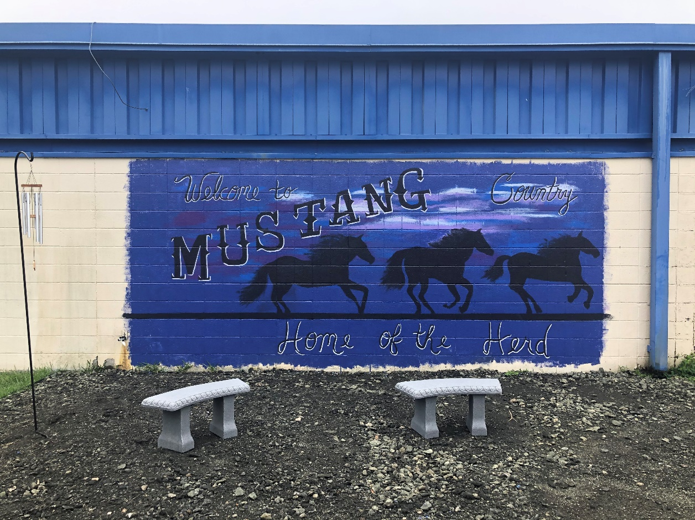

Mural painted by the Burkeville Art class, Student Council, and Graphic Design class.

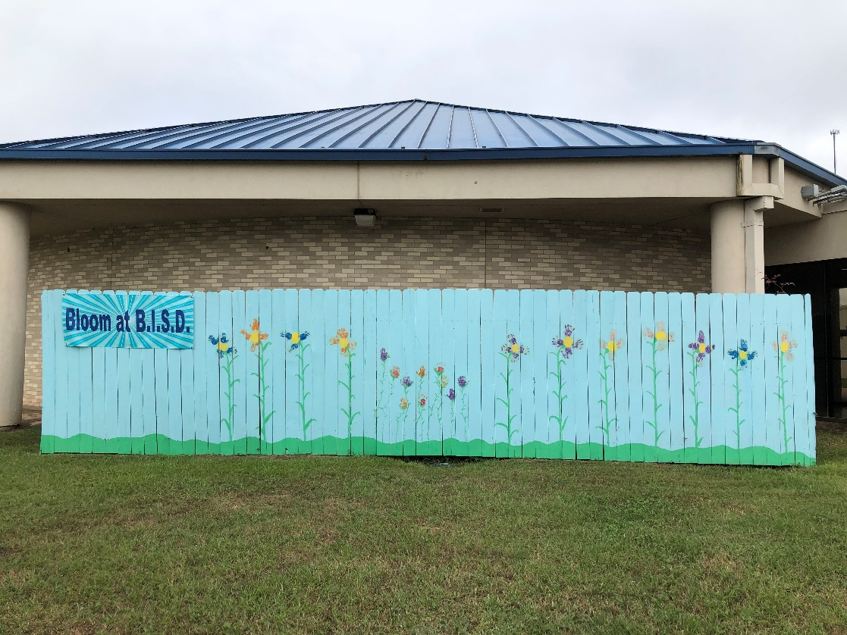

Mural painted by our Pre-K and Kindergarten classes.

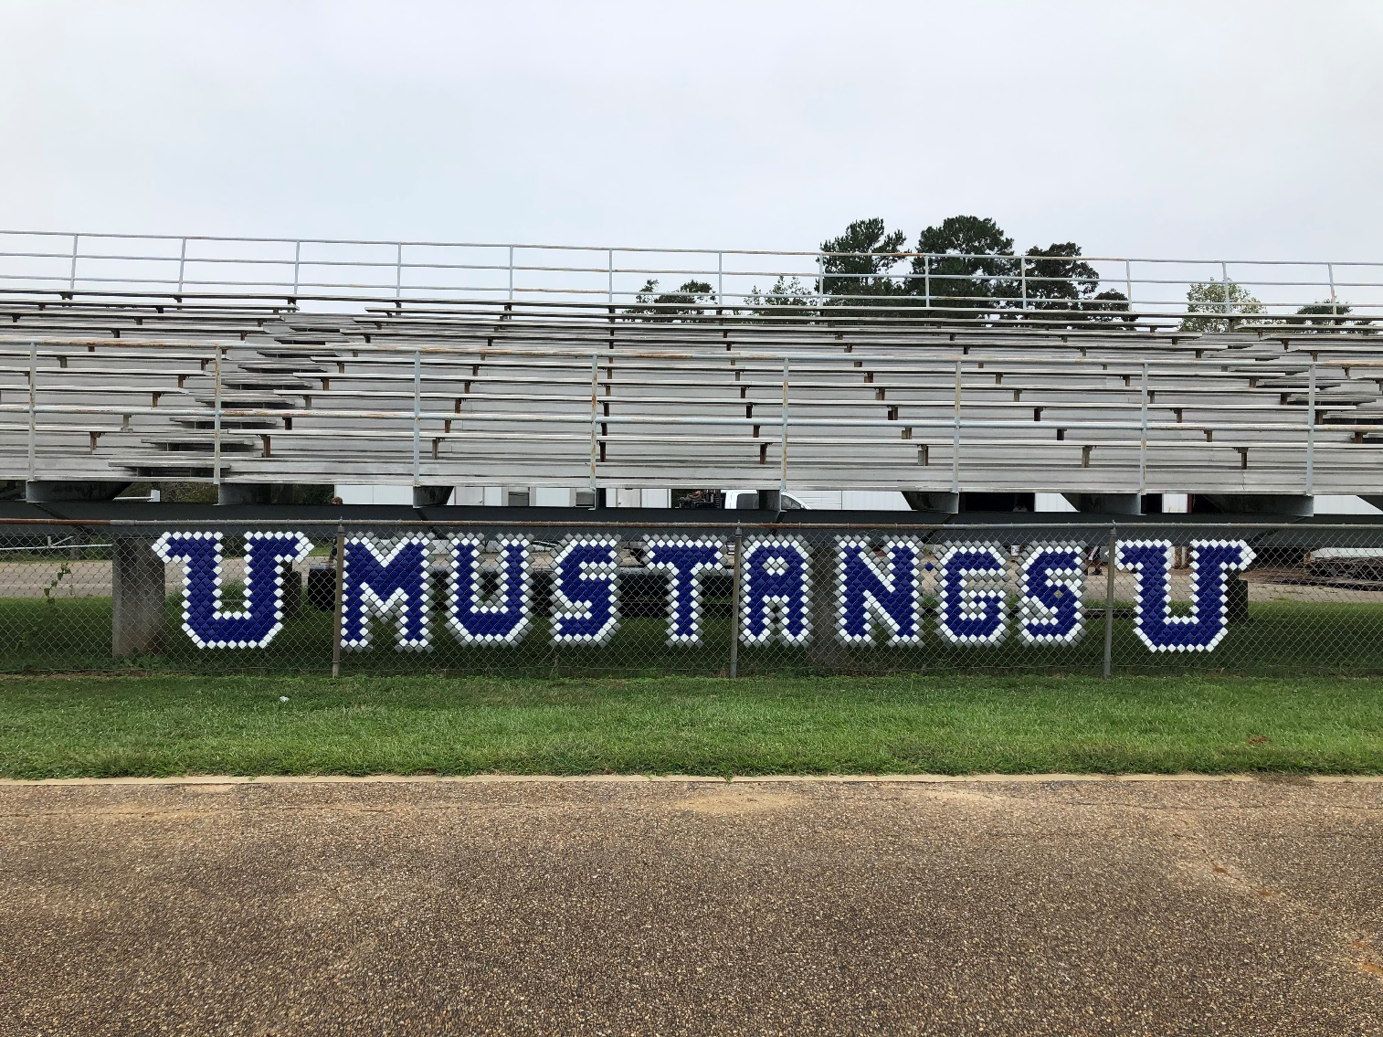

Chain link spirit cups displayed by Student Council at the football field.

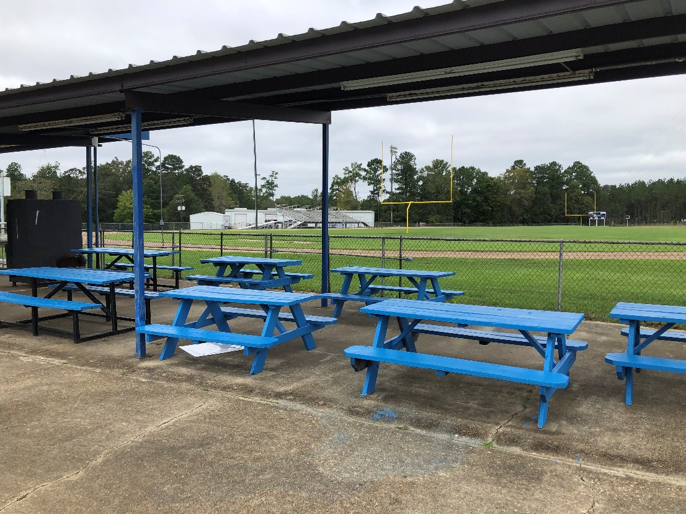

Picnic tables painted and placed by the Burkeville Baptist Church.

Goal posts repainted by our School Board President.

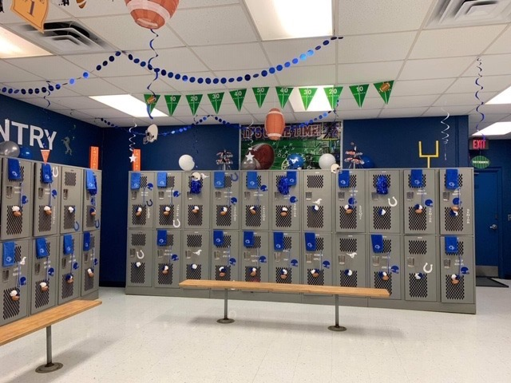

Football locker room decorated by PTO and Student Council.