Texas Association of Student Councils and Texas Association of Secondary School Principals
TASC Annual Conference 2023
Continuing Professional Education (CPE)

Name: School District:

School Name: City:

DATE | Session | Presenter | Length of Session
 | New to Conference | Lianna Gantz, Christy Reuter, and Wilton Allen | 30 minutes
 | Advisor Session with Lamarr Womble | Lamarr Womble | 40 minutes
 | Advisor Session with Chris Collins | Chris Collins | 40 minutes
 | Advisor Session with Jesse Lebeau | Jesse Lebeau | 40 minutes
 | New Advisor Training | Cheryl Royal/Jennifer Nguyen | 40 minutes
 | 35 in 35 | Mary Whittenberg | 40 minutes
 | First General Session | BOD and Jesse Lebeau | Two hours 30 minutes
 | Second General Session | BOD and Chris Collins | Two hours 30 minutes
 | Third General Session | BOD and Alex Sheen | Two hours
 | Advisor Meeting | Patty Wangler and Archie McAfee | 40 minutes
 | List any other session attended
 |  |  | TOTAL:
It is the responsibility of the attendee to keep an accurate account of CPE credit hours earned and to give a copy of that documentation to the appropriate person at his/her School District.

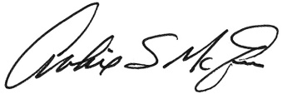
SBEC Provider Number for TASSP/TASC/TAFE: 500-111
Texas Association of Student Councils
1833 South IH-35, Austin TX 78741
Archie E. McAfee, TASSP Executive Director Participant Signature Date Total Hrs.

