The first ever Coast to Coast Leadership Skills Training
is open for registration NOW! Join the Texas delegation!
Student Council experts from seven states are combining
their knowledge and skills to provide this training.
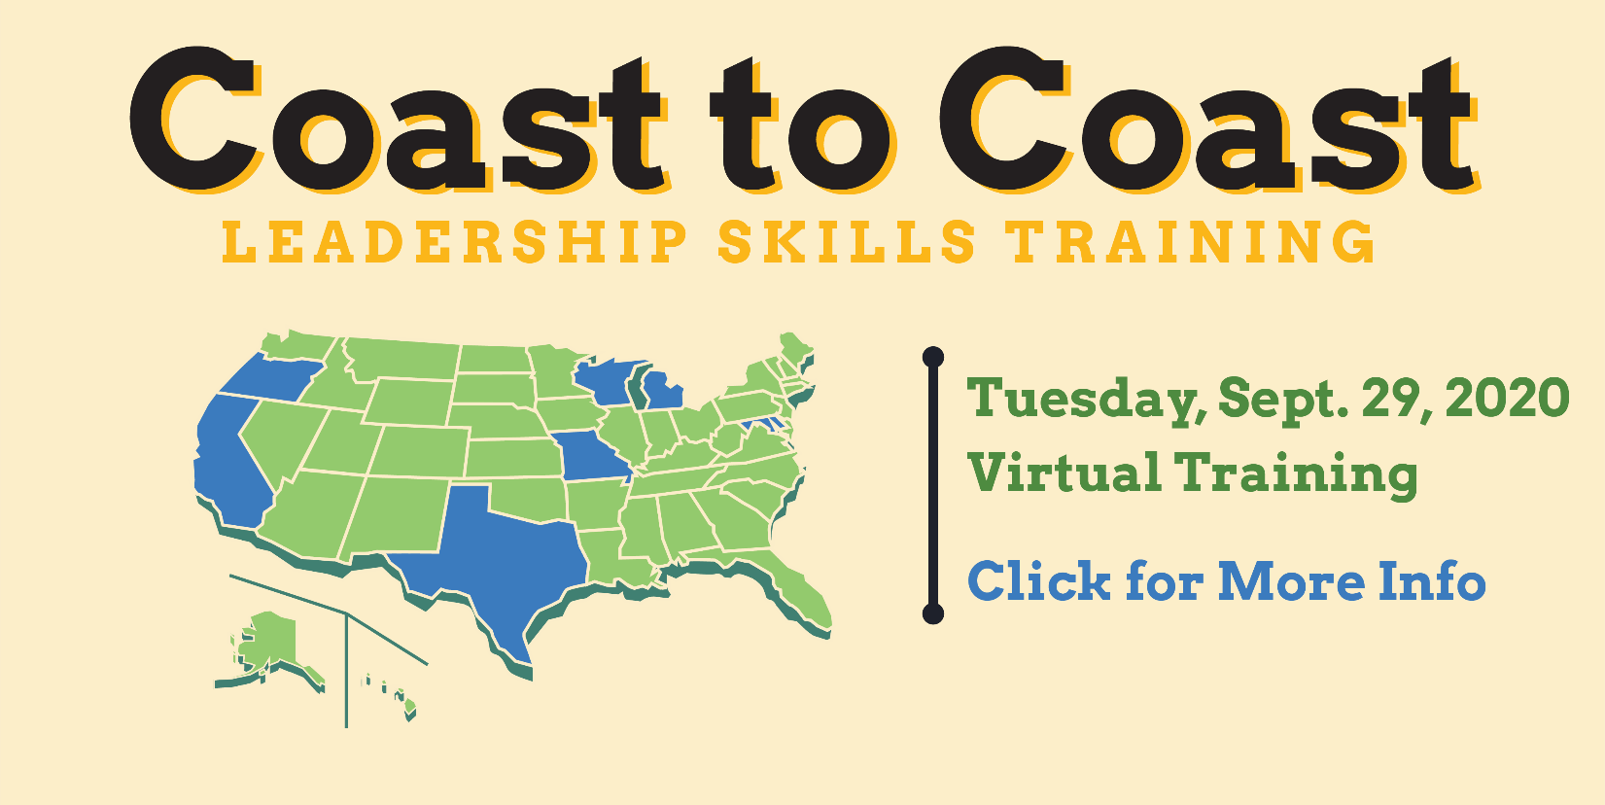
Deadline to register is September 21, 2020.
Workshops include:
- Parliamentary Procedure (led by the National Association of Parliamentarians Director)
- Effective Meeting Skills
- Group Dynamics
- Empowering Student Voice
- Effective Communication
- Elections + Voting
- Middle School Magic
- Equity/Social Justice
- Mental Health Awareness

This Tuesday evening experience is tailored for new ML and HS leaders.
Interact with student leaders and advisors from across the US!
Gain expertise to build a successful year in this time of change.
CLICK HERE TO REGISTER
COAST TO COAST TRAINING

