THE SKY’S THE LIMIT FOR YOUR
STUDENT COUNCIL AT THIS YEAR’S
NASCCONFERENCE

The TASC delegation travels to Boston, MA, June 22 for the 2017 NASC Conference. This year’s NASC National Conference, held in partnership with The Pinkerton Academy in Derry, NH, will bring together almost one thousand student leaders and advisors from across the country for a three-day event.
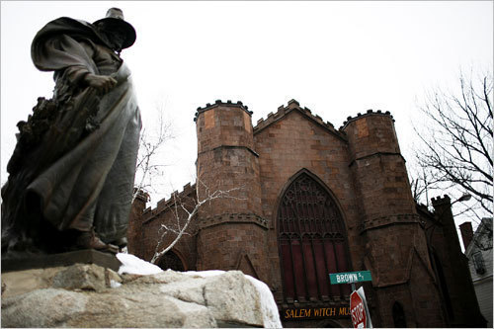
A fun filled pre-trip is planned. We plan a visit to Salem, MA, Thursday afternoon. Friday features trips to the NH coast including Portsmouth, the third oldest city in the US and one of the greatest port cities of the 18th and early 19th century, which still has a working waterfront and a vibrant, historic downtown as well as time at the Boardwalk at Hampton Beach. The next two days will be spent in Boston with opportunities to see the Freedom Trail, the Boston Waterfront with the Tall Ships, Harvard, Fenway Park, the North End, and the Boston Public Gardens. The group will stay at the Courtyard in Nashua, NH.

June 26, we will head to The Pinkerton Academy for the conference. #NASCconf17. Meals will be eaten at the conference site June 26, 27, and 28.

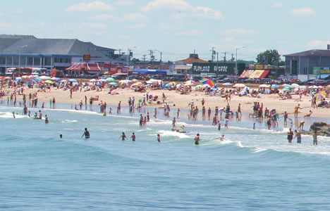
Our adventure doesn’t end with the conference. June 28 after the conference we will choose between a tour of Boston Harbor on the Codzilla or a trip back to the Boardwalk at Hampton Beach for fireworks.

We will return to the airport in Boston by 11:40 am, June 29.

Delegates must arrive at the Boston Logan International Airport no later than 1:00 pm, June 22. Departing flights should leave no earlier than 1:00 pm on June 29. Flights outside of those times will result in the individual’s having to arrange transportation to and from the hotel to the airport. The Boston Logan Airport is a little over an hour’s drive from the hotel (and more during rush hours) so flights must meet times listed above

You can watch a video and see additional information about the 2017 NASC Conference on the NASC website. The conference will be held at Pinkerton Academy where Robert Frost once taught.

*See below if your council will not be part of the TASC Pretrip but wants to order shirts and/or trading items for the conference.

Costs for the TASC/NASC Trip include the following:
- 20 Trading pins
- 9 shirts (three each of three designs) to wear and to trade
- Hotel for the entire stay
- Travel on site (excludes flights to and from Boston
- Meals (other than those eaten at the airport)
- Tours/admissions, etc.

Attendees are responsible for the following:
- Registration for the NASC Conference
- Travel to and from Boston
- Any meals eaten at the airport
- Souvenirs and snacks other than those provided

Costs for the trip in addition to registration with NASC, travel to/from Boston and meals at the airport
If registration with TASC and full payment is made to TASC by April 14 (includes $500 nonrefundable deposit)
Students (four to a room): $920
Adults (two to a room): $1160
Adults requesting private room: $1705

If registration with TASC and $500 nonrefundable deposit to TASC are made by April 14 and final payment to TASC is made by May 15
Students (four to a room) $970
Adults (two to a room) $1210
Adults requesting private room: $1755

Registration Procedure:
- Registration will incur a $500 nonrefundable deposit per person.
- Register with TASC using the link to registration on the TASC website: Events/NASC Convention
- Send $500 non-refundable deposit or full payment per person payable to TASC, 1833 S. IH 35, Austin, Texas, 78741 by April 15. You can also pay online with a credit card or PO.
- Full payment postmarked by April 14 is $920 per student or $1160 per adult.
- Full payment not made by April 14 must be postmarked by May 25, and will incur an additional $50 charge per person.
- Register with NASC. Early bird NASC registration is $385. Schools must be members of NASC, and registration must be made by April 14. Regular NASC registration is $415 per person and must be postmarked by May 19. Those fees are for member schools. Nonmember rates are $485 and $515 per person respectively.

Consider applying to present a workshop at this year’s NASC conference. It is an honor to be selected to present to your peers from around the country. See the NASC website for application forms.

Any additional questions can be directed to Terry at terry@tassp.org or at 512-443-2100 ext. 233.

*Trade items (shirts and pins) are a large part of the NASC Conference Experience. If you have individuals attending the conference who want shirts and/or pins, they may be ordered as follows:

______ Three of each of the three shirts (Full Conference Package) + 20 trading pins $110.00

______ One set of 20 trading pins (Trading Pins Package) $22.00

______ One of each of the three shirts (Conference Shirt Package) $33.00

Shirts must be ordered no later than May 15 as they must be printed.

Shirts and trading items can be delivered to the State Steering Committee Retreat if your school is in attendance at that. If not, we will send you an invoice to include shipping. Estimate shipping at $12 per Full Conference Package, $8.00 per Trading Pins Package, or $10.00 per Conference Shirt Package. We will invoice you for the best UPS rate we can find.

