TEXAS ASSOCIATION OF STUDENT COUNCILS
TASC TOP FIVE PROJECTS COMPETITION

MIDDLE LEVEL

Entry Cover Sheet
School Name: | School District:
Deweyville Elementary | Deweyville ISD
School Address: | Size of Community:
43200 TX ST Hwy 87 S | 1500
City/State: | Zip:
Orange, TX | 77632
School Phone: | School Fax:
409-746-2681 | 409-206-2697
Advisor Name: | Advisor E-Mail:
Vicki Long  Wendy Totino | vlong@deweyvilleisd.com wendytotino@deweyvilleisd.com
Principal Name: | Principal Signature:
LaJuan Addison | Mrs. LaJuan Addison
Project Name: | Project Dates:
Housing and Feeding Our Heros | May 29, 2018 – May 30, 2018
Total Number of Students in Council: | Number of Members Involved in Project:
16 | 16
Total Number of Students Enrolled in School: | Number of Other Students Involved in Project:
265 | 50
Total Number of Faculty Enrolled in School | Number of Faculty Involved in Project
31 | 18
Number of Community Groups Involved in Project | Number of Community Members Involved in Project
4 | 30
This information must be submitted online.
.

This application must be submitted online via the TASC website.
Upload your photos, newspaper articles, etc. online as well. Scan all pages into one document and upload.
Name of Project: Housing and Feeding Our Heroes
Purpose and Objective: The purpose of the project was to give a nice cool place for the heroes to sleep and a nice warm dinner and “home cooked” meal. The objective was to get students involved as part of our community service and helping others.
Brief Description:
A group of firefighters and first responders who were raising money for wounded firefighters and officers by bicycling from New Orleans to San Antonio made arrangements to stop in Deweyville for a night as they pass through our area. This was a great honor to help head up and participate in. The Elementary Student Council offered to serve dinner to the men and women of the group on May 29th. The riders were treated to a feast of brisket, baked beans, potato salad, and tea and lemonade. This meal was served by our student council members as well as help from the High School NHS and student council members. The Deweyville Elementary Council volunteered to be onsite to welcome the bike riders. The student council members helped to unload luggage and sleeping bags and air mattresses into our practice gym where they would be sleeping. The riders were then given time to take nice hot showers and to get cleaned up for dinner using the showers in our athletic department. Our student council leaders were able to visit with the firefighters and police officers who were among the riders. This was a great way to honor those helping to raise money for those who were wounded or killed in the line of duty.

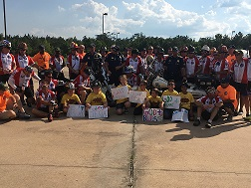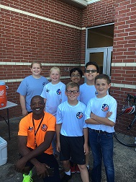

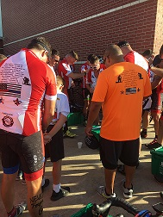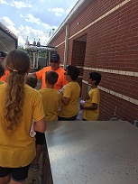

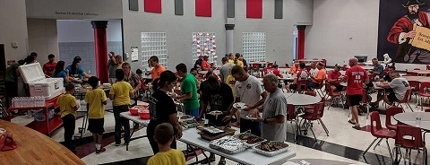
To the Members of the Top 5 Project Competition Committee,

It is my pleasure to write this letter of evaluation for Deweyville Elementary 5th Grade Student Council. The students and advisors who work within this group always go up and beyond the expectations that are set for them.
In May 2018, we were notified that a group of firefighters and police officers who would be bicycling from New Orleans to San Antonio to raise money for those wounded in the line of duty or for the families of those killed in line of duty needed a facility that could house them overnight and that their journey would bring them through our community on May 29, 2018. When it was announced by our superintendent, Dr. Keith Jones, that he was looking for any organizations that were willing to help, our student council was the first to volunteer.
The advisors for the group had the students make posters to welcome the riders to our school. The student council members then helped to unload two utility trailers that carried all the luggage and bedding into our practice gym. Once all of this was done, the students moved on to get things ready for the evening meal that would be served once the participants had showered and were ready.
Although our students are only 5th graders, they do not let anything stop them. They were hustling all evening making sure that anyone who needed more food got it and that no one’s drinks were empty. It was great seeing the students step up and serve these heroes.
The students made such an impact that the riders asked that they be allowed to be there when they were ready to leave to continue their ride. The riders asked our student council members to join them in prayer and kept thanking them for all they did for them. Each of our student council members were then given a shirt that is given to those that help along the route.
I hope that the committee sees fit to award Deweyville 5th Grade Student Council this award for their hard work and dedication to helping others.

Sincerely,
Brandi Zirlott

Brandi Zirlott
5th Grade Teacher
Deweyville Elementary

